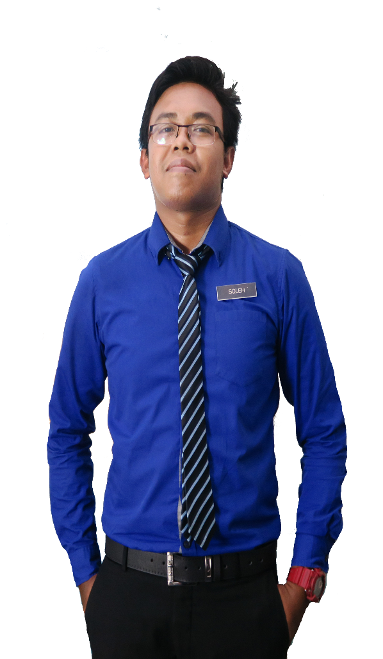

100%%

90%

90%

90%

90%

90%

90%

90%

90%

90%

**LANGUAGES**

Malay

English

Management

Teamwork

Leadership

Communication

**PERSONAL SKILLS**

Microsoft Excel

Adobe Photoshop

Microsoft PowerPoint

Microsoft Word

**COMPUTER SKILLS**

**PROF. DR. MOHAMAD SUFFIAN MOHAMAD ANNUAR**

Professor

Kolej Kediaman Tun Syed Zahiruddin

Universiti Teknologi Mara

[suffian_annuar@um.edu.my](mailto:suffian_annuar@um.edu.my)

+60160-2190 5697

**REFERENCES**

* Graphic Design Award 2015, Kuala Lumpur
* Anugerah Guru Cemerlang SMK Bandar Baru Sungai Buloh 2016
* Larian Hari Sukan Negara 2016, UiTM Kampus Puncak Alam
* Mount Kinabalu Hiking Expedition
* Volunteer for SUKMA 18, Pahang Darul Makmur
* Creative and Innovation Awards 2017

**ACHIEVEMENT**

**SMK TUNKU ABDUL RAHMAN GEMAS**

Chemistry Teacher

2016 - 2018

* Implements curriculum objectives and goals using effective teaching techniques and materials.
* Develops, in a cooperative manner with the principal and curriculum facilitators, a plan for the improvement and enrichment of instruction.
* Implements curriculum objectives and goals using effective teaching techniques and materials.
* Develops, in a cooperative manner with the principal and curriculum facilitators, a plan for the improvement and enrichment of instruction.

Chemistry Teacher

Gender

Race

Marital Status

Religion

Date of Birth

Nationality

Height

Weight

: Female

: Malay

: Married

: Islam

: 06 May 1988

: Malaysian

: 157 cm

: 58 kg

**PERSONAL DETAILS**

2016 - 2018

**SMK BANDAR BARU SUNGAI BULOH**

**WORK EXPERIENCE**

Sijil Pelajaran Malaysia (SPM)

**SEKOLAH MENENGAH KEBANGSAAN SAINS SEREMBAN**

2016 - 2018

**UNIVERSITI SAINS MALAYSIA (USM)**

Diploma in Science (Hons) Chemistry

CGPA: 3.91

2016 - 2018

Bachelors of Education in Science (Hons) Chemistry

CGPA: 3.91

2016 - 2018

**UNIVERSITI KEBANGSAAN MALAYSIA (UKM)**

**EDUCATION**

MUHD SOLEH

**MUHAMAD AMIRUL AKMAL BIN MUHD**

Creative Resume, Lot 234,

Jalan Lok Yu, 74300

Petaling Jaya, Selangor

+6013-2805916

resumecreative@yahoo.com

Master’s degree in Science with four years’ experience teaching high school Science, Chemistry, and Additional mathematic. Certification in teaching Science and also professional in graphic design and video editor.